1)

2)

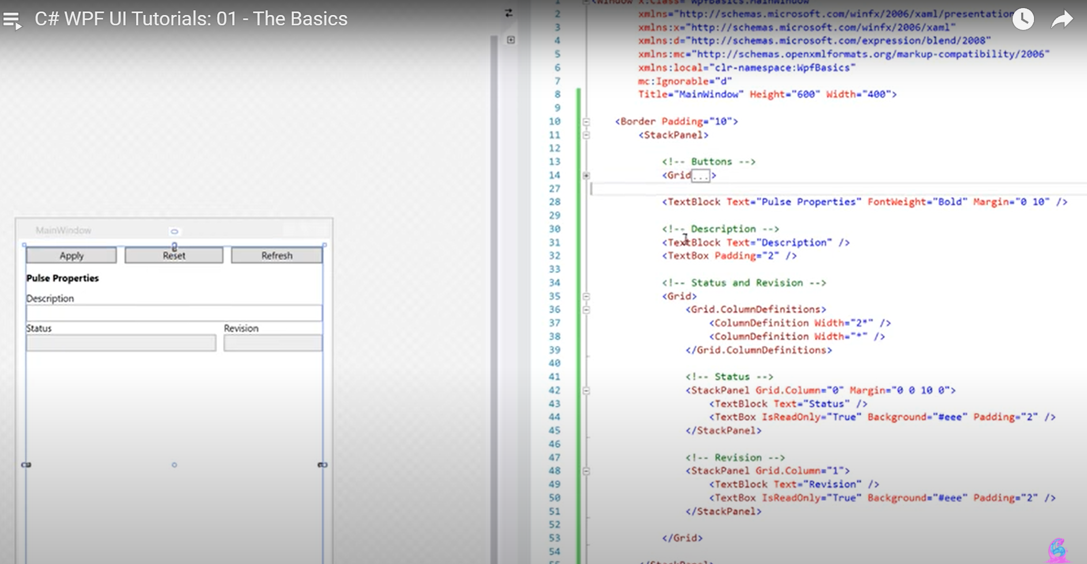

3)

4)

5)

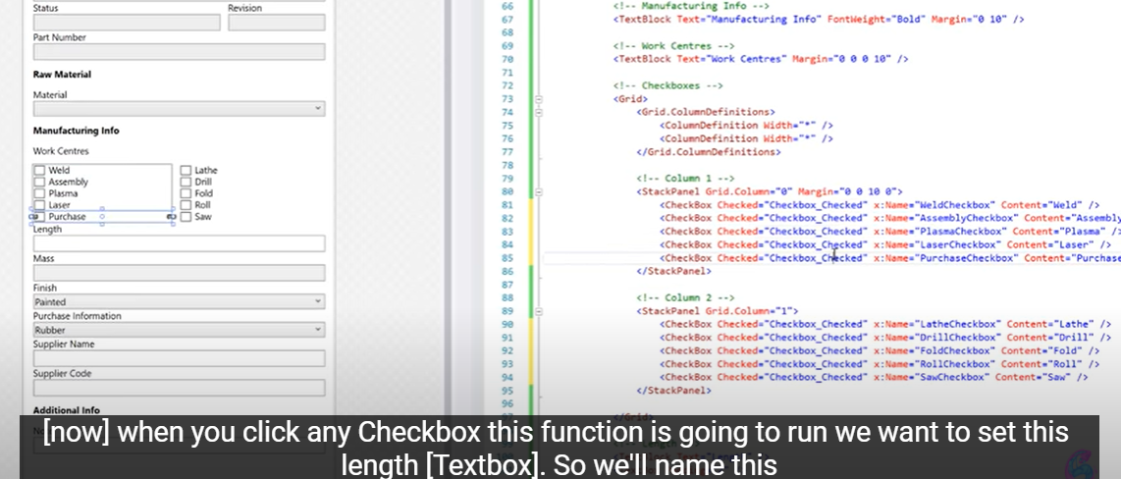

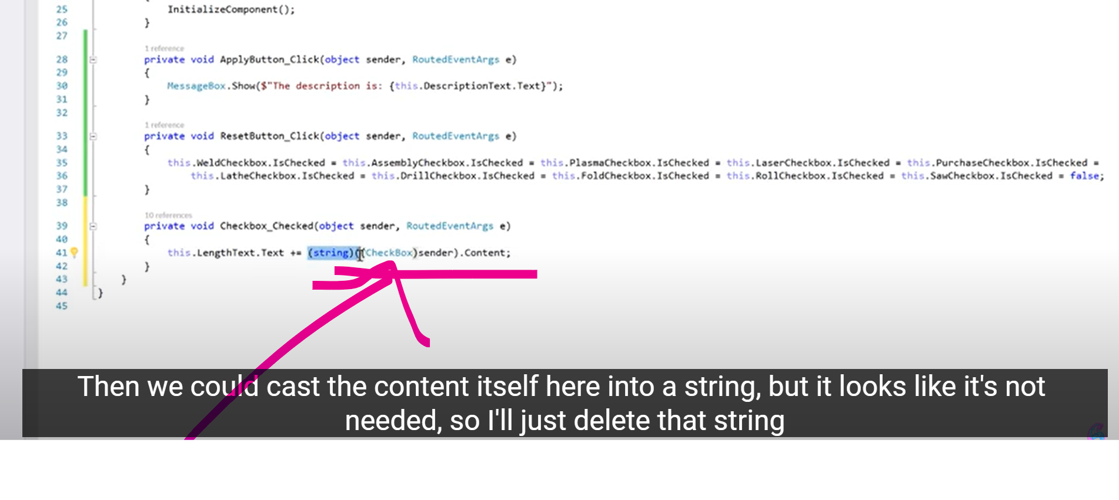

To access content in checkbox

6)

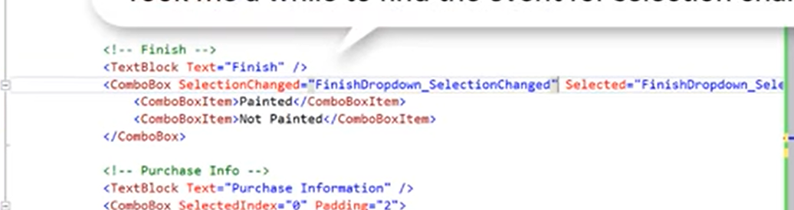

7)

7)text changed event

